Supporting Information
Life on the edge: industrial footprint and edge effects variably influence the spatial distribution of a boreal small mammal.

Equation S1: The general format of generalized linear mixed models with a negative binomial distribution and log-link function used to model red squirrel responses to landscape structure. Detections_{ijk} was the number of independent detections of red squirrels at site i in array j during month k, which arose from a negative binomial distribution with an expected count of independent detections of red squirrels at site i in array j during month k of μ_{ijk}, and an overdispersion parameter θ. In each model, β_{n} was the linear coefficient for landscape covariate x_{n}, and v_{i(j)} and u_{j} were nested random intercepts of site and array, which were assumed to have a normally distributed variance. All models were fit using the glmmTMB package (Magnusson et al., 2017) using maximum likelihood with the Laplace approximation. All explanatory variables were scaled using standardized z-scaling to improve model convergence and facilitate comparison of relative effect sizes.

$$η_{ijk}=β_{0}+ β_{1}x_{1,ijk}+…+ β_{n}x_{n,ijk}+ u_{j}+ v_{i(j)}$$
$${log(μ}_{ijk})=η_{ijk}$$
$${detections}_{ijk} \sim NegBin(μ_{ijk}, θ)$$
$$u_{j} \sim Normal(0, σ_{u}^{2})$$
$$v_{i(j)} \sim Normal(0, σ_{v}^{2})$$

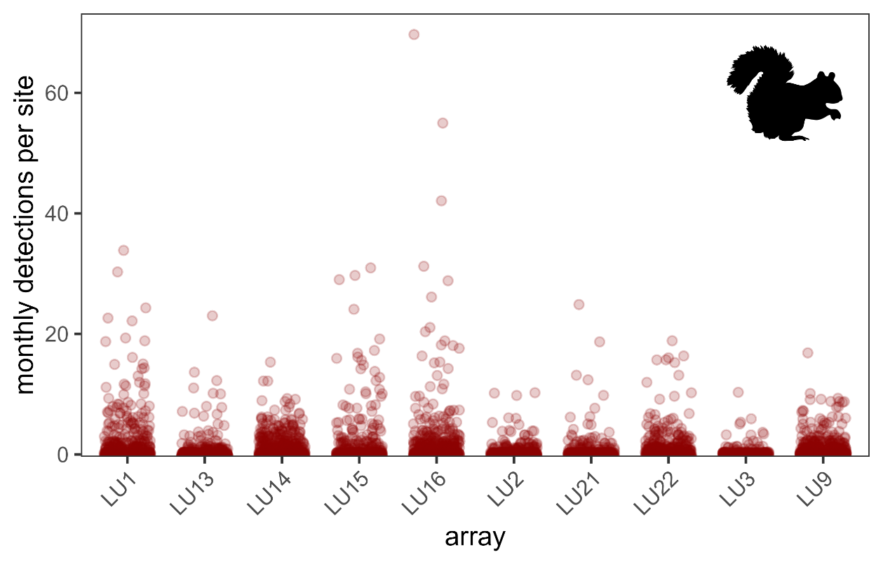
Figure S1. Distribution of monthly independent detections of red squirrels for 430 camera trap sites distributed across 10 arrays. Independent detections of squirrels were defined as detections of red squirrels that were >30 minutes apart at a given camera trap site. Our final monthly dataset represented 4918 camera-months of data with a mean monthly detection rate of 0.93 squirrels.

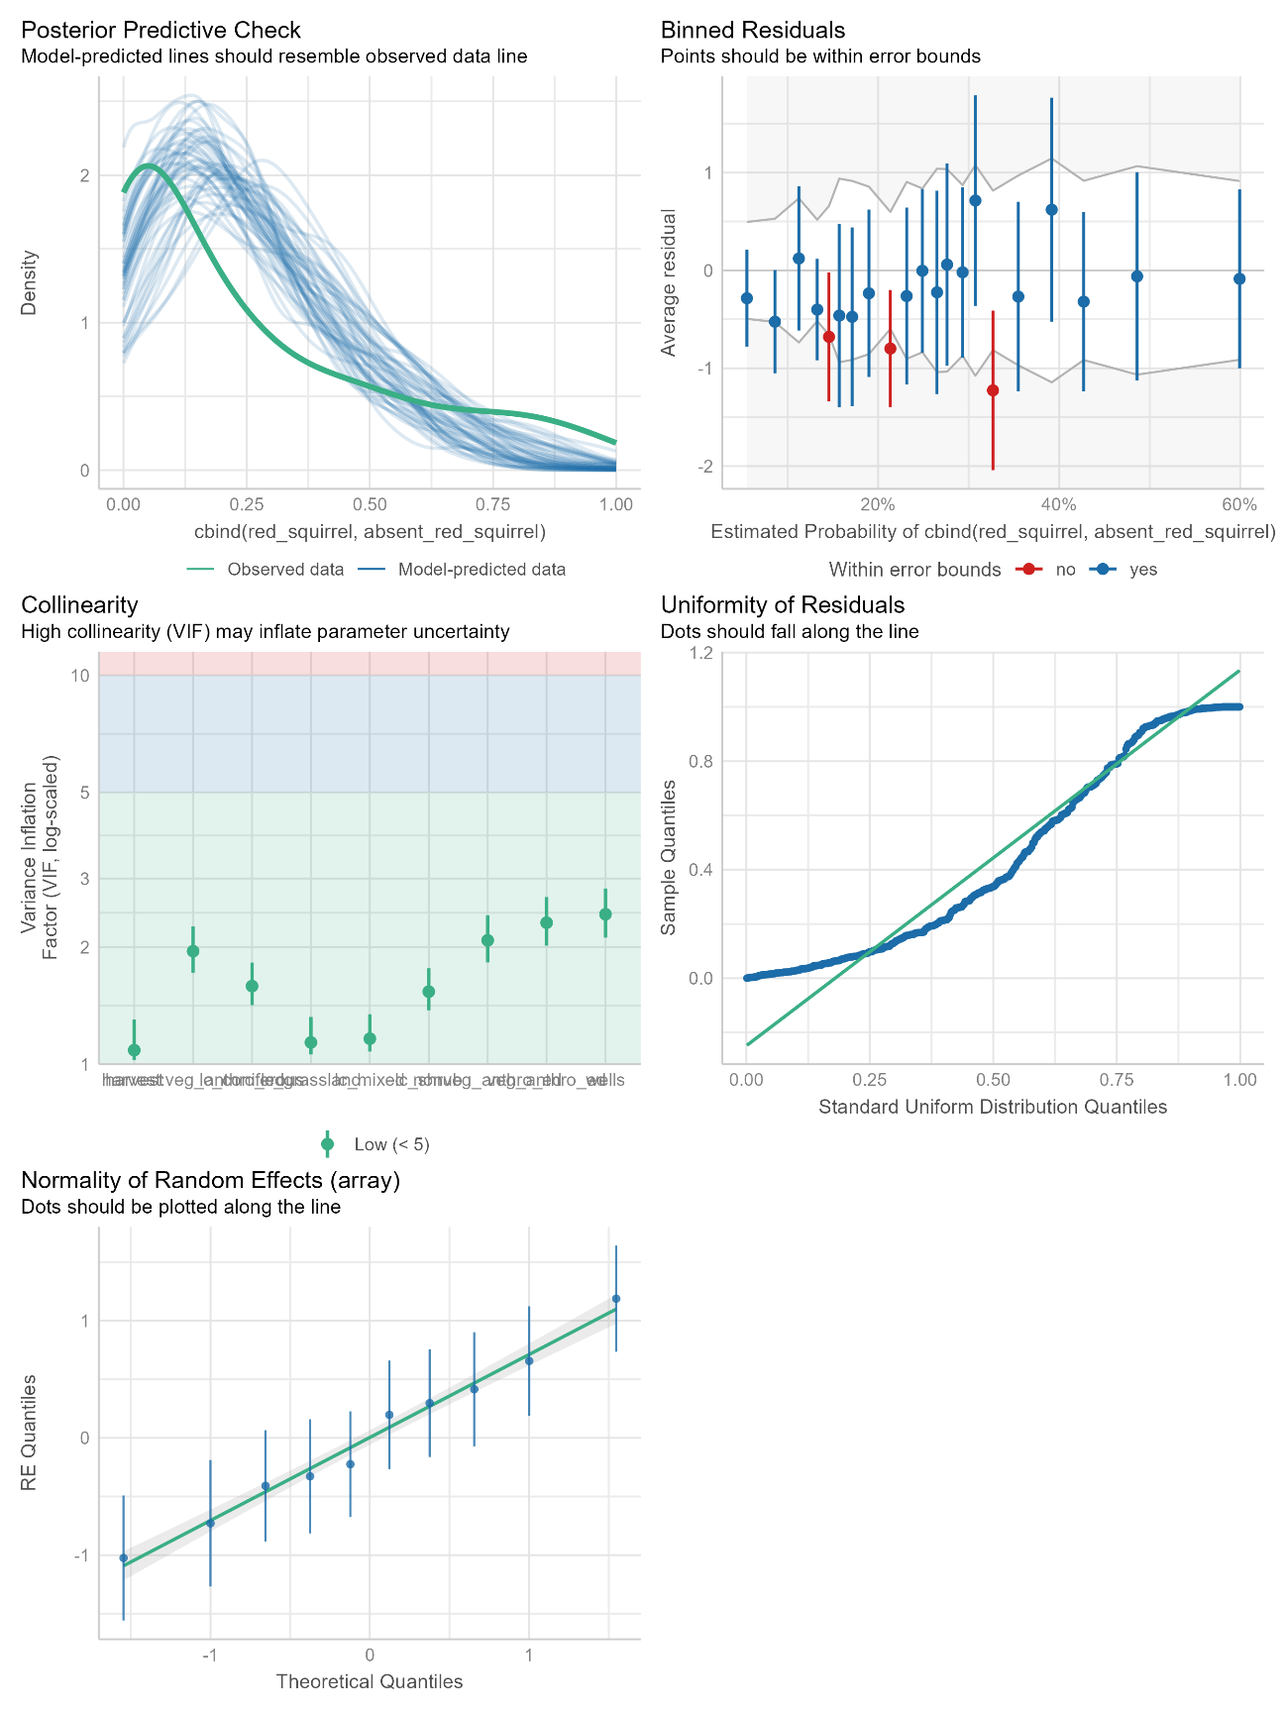
Figure S2. Model diagnostics for the top-performing model explaining red squirrel detections as a function of natural land cover, edge density, and cumulative site disturbance. Model was fit as a mixed-effect negative binomial model with nested random effects for camera site and camera array.
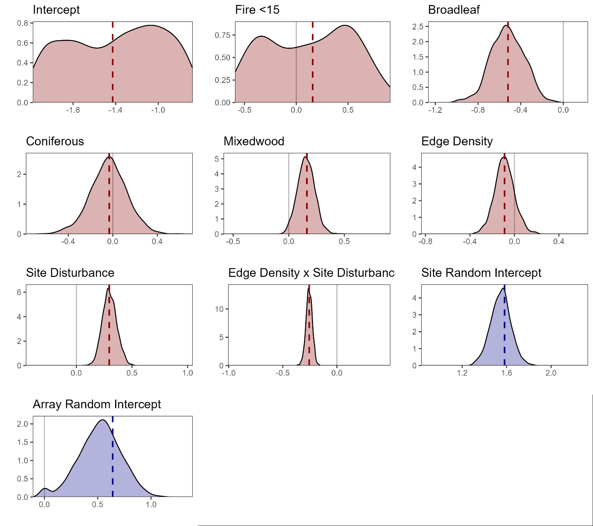
Figure S3. Density of coefficient estimates (red) and random intercept variance estimates (blue) for 1000 fitted models of red squirrel detections as a function of landscape structure. Data for simulations was generated using the top-performing model from model selection as a ‘true’ data-generating process. For a hypothetical scenario of 10 arrays and 43 cameras per array, we simulated 1000 new datasets by sampling landscape covariates from their observed distributions and generating squirrel detections for each camera site using the random variance structure and negative binomial distribution from our top-performing model. We refit the model to each simulated dataset to build an empirical distribution of coefficient estimates, then assessed the empirical precision (standard error) and bias (mean) of our fixed effect and random effect estimates compared to the top model (Zuur et al., 2016). Dotted vertical lines represent the coefficient/variance from the ‘true’ data generating model.

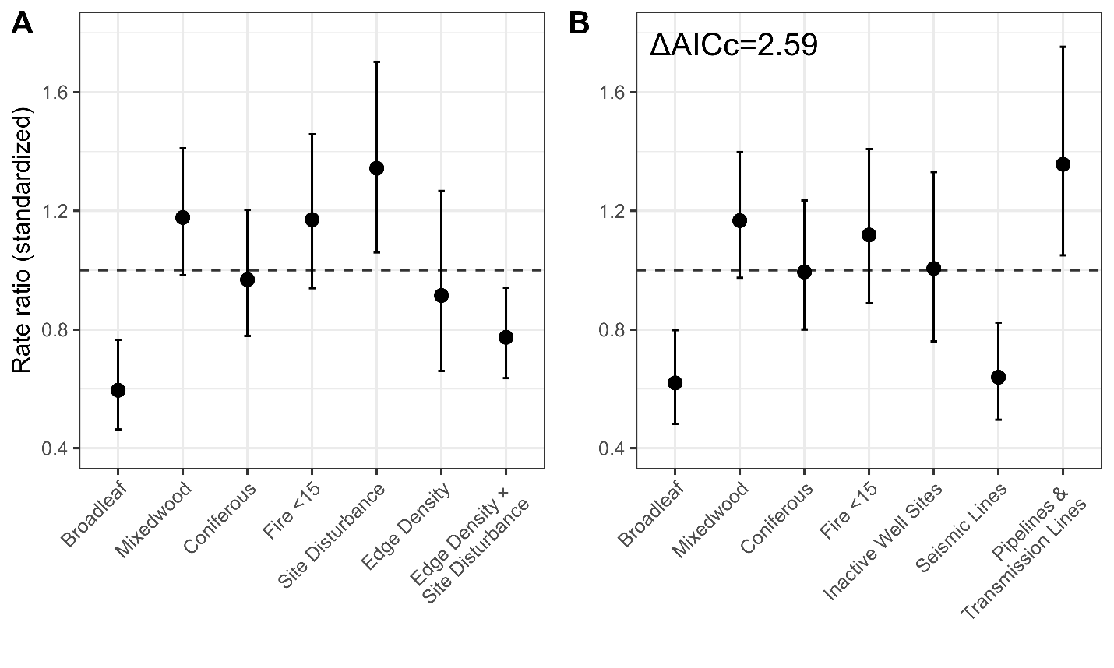
Figure S4. Rate ratios with 95% confidence intervals for standardized coefficients for [A] the top-ranked model explaining red squirrel detections as a function of edge density and cumulative site disturbance, and [B] the second-ranked model (ΔAICc = 2.59, AIC_{w} = 0.153) explaining red squirrel detections as a function of anthropogenic disturbance type. Both models were fit using mixed-effect negative binomial models with nested random effects for camera site and camera array.

Table S1. Covariates describing the composition of natural habitat, composition of anthropogenic features, and landscape configuration in negative binomial models of red squirrel abundance in the Boreal Plains. Each category of covariates was included in models at a separate spatial scale. Within each category of predictors, we fit a model using all predictors at 22 spatial scales (50 m–5000 m) and compared the Akaike Information Criterion corrected for small sample size (AICc) scores across spatial scales to determine which one was best supported for statistical modelling.

Covariate | Modelled Scale | Median (5%, 95%) | Description
Natural land cover | 100 m
Fire <15 |  | 0.00 (0.00–0.61) | Proportion cover of fires from 0 to 15 years of age and any intensity.
Broadleaf |  | 0.03 (0.00–0.81) | Proportion cover of broadleaf forest (>75% broadleaf species).
Coniferous |  | 0.35 (0.01–0.85) | Proportion cover of coniferous forest (>75% conifer species).
Herbs |  | 0.00 (0.00–0.15) | Proportion cover of herbacous plants.
Mixedwood |  | 0.03 (0.00–0.33) | Proportion cover of mixedwood forest.
Shrubland |  | 0.00 (0.00–0.13) | Proportion cover of shrubby plants.
Wetland |  | 0.01 (0.00–0.31) | Proportion cover of wetlands.
Treed Wetland |  | 0.15 (0.00–0.72) | Proportion cover of treed wetlands (e.g., spruce bog).
Disturbance composition | 4250 m
Roads |  | 0.00 (0.00–0.01) | Proportion cover of roads (paved and unpaved).
Seismic Lines |  | 0.01 (0.00–0.03) | Proportion cover of all conventional and low-impact seismic lines.
Active Well Sites |  | 0.00 (0.00–0.02) | Proportion cover of well sites pre-cleared for drilling or actively used for drilling.
Inactive Well Sites |  | 0.00 (0.00–0.02) | Proportion cover of reclaimed, restored, or abandoned well sites
Industrial Facilities |  | 0.00 (0.00–0.08) | Proportion cover of industrial sites (mines, processing facilities, tailings ponds).
Harvest <15 |  | 0.00 (0.00–0.10) | Proportion cover of timber harvest blocks from 0 to 15 years of age.
Pipelines & Transmission Lines |  | 0.01 (0.00–0.05) | Proportion cover of pipelines and transmission lines.
Landscape configuration | 2250 m
Cumulative Site Disturbance |  | 0.04 (0.00–0.19) | Sum of the footprint of all anthropogenic disturbances at a site.
Edge Density |  | 71.19 (13.86–279.67) | Total density of natural habitat edges created by anthropogenic disturbances (m/Ha).
Mesh Index |  | 126.03 (41.22–438.25) | Mean patch size adjusted for landscape area. Represents patch size.
Cohesion |  | 99.59 (98.17–99.96) | Probability of any two points of natural habitat being connected. Represents connectivity.
Shannon's Evenness |  | 0.64 (0.41–0.82) | Evenness of land cover types (composition). Represents land cover dominance.

Table S2. Spearman’s correlation (r) exceeding an absolute value of 0.50 for the final dataset used to model red squirrel detections. Roads were not included in any models due to their high correlation with other disturbance metrics. The effect of other correlated variables was assessed using model diagnostics and variance inflation factors after model fitting.
Covariate 1 | Covariate 2 | r
Contagion | Shannon's Evenness | -0.96538
Seismic Lines | Edge Density | 0.936006
Edge Density | Cohesion | -0.91329
Seismic Lines | Cohesion | -0.89965
Fire <15 | Shrubland | 0.821534
Industrial Facilities | Site Disturbance | 0.764099
Roads | Well Sites | 0.729411
Roads | Active Well Sites | 0.728017
Roads | Site Disturbance | 0.688302
Harvest <15 | Harvest | 0.678449
Pipelines & Transmission Lines | Site Disturbance | 0.657229
Active Well Sites | Inactive Well Sites | 0.640814
Inactive Well Sites | Site Disturbance | 0.639989
Pipelines & Transmission Lines | Roads | 0.634861
Pipelines & Transmission Lines | Active Well Sites | 0.633138
Active Well Sites | Site Disturbance | 0.596467
Edge Density | Site Disturbance | 0.585548
Inactive Well Sites | Edge Density | 0.580486
Roads | Inactive Well Sites | 0.568807
Industrial Facilities | Roads | 0.558395
Cohesion | Site Disturbance | -0.54459
Broadleaf | Coniferous | -0.50601

